How to update your email signature
from Outlook desktop

In Outlook navigate to File then Options

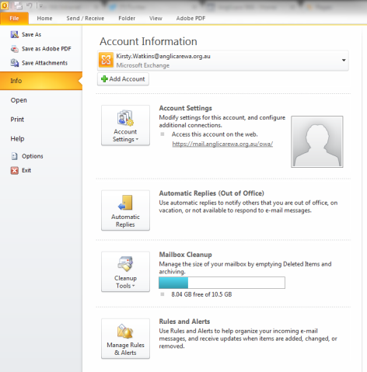

Click Mail then Signatures
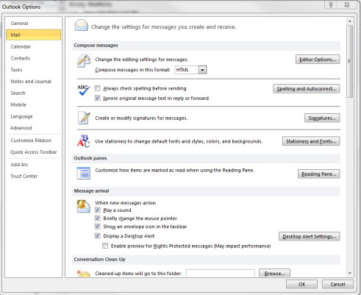

Please copy the whole email template, ensuring you copy the four social media icons and banner which have website links embedded in them.

Once the template is copied into Outlook, fill out your relevant contact details and press ‘OK’ to save.

Signature template

Firstname Surname
Pronouns: She, her, hers
Job Title
Team name

I work Mon, Tue, Fri, 9am-2pm
T 08 xxxx xxxx | M xxxx xxx xxx
F 08 xxxx xxxx
GPO BOX C138, East Perth WA 6892
anglicarewa.org.au
We acknowledge Aboriginal people as the Traditional Custodians of this land.
We pay our respects to their strength, cultural resilience and the Elders past and present.

How to update your default font in Outlook desktop

- After you have saved your signature, select ‘Stationery and fonts’
- ‘Under ‘New mail messages’, select ‘Font…’
  - In ‘Font’, select ‘Century Gothic’ from the drop-down box
  - In ‘Font style’, ensure ‘Regular’ is selected
  - In ‘Size’, choose any number between 10-12
  - In ‘Font colour’, click the arrow to open the drop-down colour picker, then choose ‘More colours’
  - Ensure ‘Colour model’ is set to RGB
  - Enter the colour code:
    - Red: 88
    - Green: 89
    - Blue: 91
    - Press ‘OK to set the colour
  - In the font dialogue box, ensure all ‘Effects’ are deselected
  - Press ‘OK’ to save font settings
- Under ‘replying ort forwarding messages’, select ‘Font…’
  - Repeat the steps above
- Press ‘OK’ to save settings
- Press ‘OK’ to close the Options dialogue box
Confirming your email signature
Once you have set up your email signature, please send a test message to marketing@anglicarewa.org.au for approval.

